Water Resources Notes

Water Cycle, Sun Energy Source

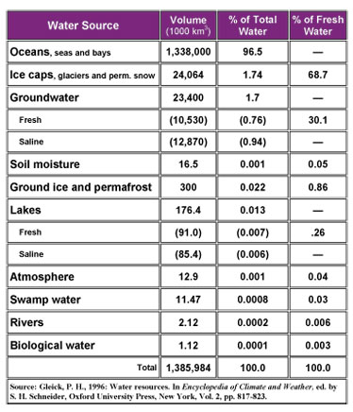

Average family uses about 1 acre foot/year – 325,000 gallons

Natural Water Chemistry

Provenance – the beginning of something .. where it came from

Water focus on most recent “cycle” from rainfall and runoff – rain “pure” less than 10 mg/l salts

Runoff picks up a “load” including dissolved solids (salts), suspended materials (small sediment/clay) and bed load

Depends on local geology – does river flow over limestone, igneous rock etc..

Groundwater in system for 10s to 1000s of years – picks up more dissolved elements (Ca, Na etc.)

Ocean Water and Great Salt Lake

* *Oceans billions of years old. Origin related to volcanoes*
* *How did it get so salty? Dissolved salts from river runoff and minerals from springs (undersea)*
* *35,0000 mg/l or 3.5% dissolved salts – sea water – 1.23 ounces salt/liter (5 tsp/oz)*
* *Great Salt Lake – 10-20% south arm and 20-30% north arm*

Water Quality Classes

* *Class I – Pristine drinking water contains 500 mg/l salts or less 0.05%*
* *Class II – drinking water*
* *500-2000 mg/l 0.3% tastes bad at 3000 mg/l*
* *Class III – 3,000 to 10,000 must be treated to drink*
* *Class IV – 10,000 mg/l 1% not drinkable or usable for some irrigation (lots of ecological uses), about 1/3 ounce of salt per liter*
* *Protection based on beneficial use*
* 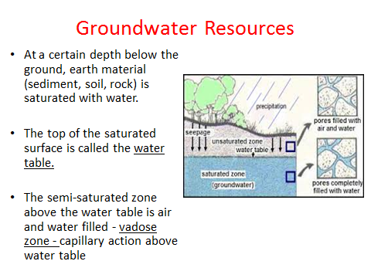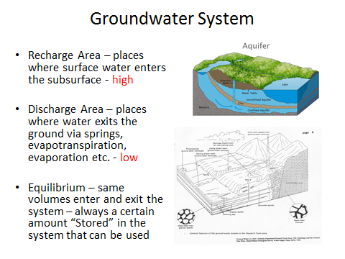

In wet years there is more recharge and discharge and more water stored in the system (water t rise)

Overall there is an average amount in the system and the water table stays at about the same elevation

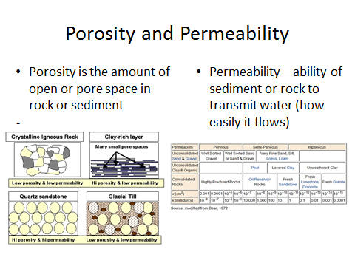

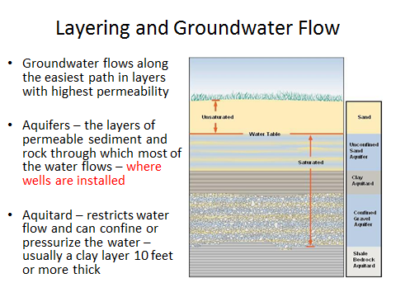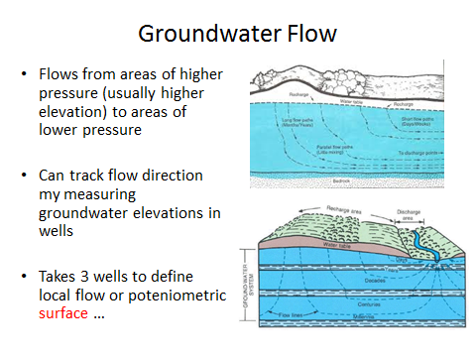

Confined means the water is under pressure and rises in the well

Artesian is a category of confined with so much pressure the water flows from a well without pumping

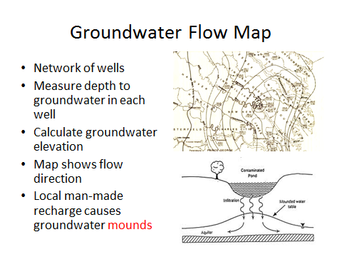

**Planning and Siting new industries -**

Avoid GW Recharge Areas, Kennecott, ATK, explosives

Avoid locations near rivers or lakes.. Geneva Steel, Western Zirconium, Tailings in Moab

Avoid area high permeability materials in subsurface

Avoid EQ, Landslide and floodplain areas, North Salt Lake

**Wetlands**

* Wetlands means "areas inundated or saturated by surface or groundwater at a frequency and duration sufficient to support, and that under normal circumstances do support, a prevalence of vegetation typically adapted for life in saturated soil conditions”.
* Wetlands generally include swamps, marshes, bogs and similar areas."
* **Wetlands reduce the amount of harmful substances that enter a stream, river, pond, or lake by slowing the water flow and filtering.**
* **When pollutants enter a wetland, before reaching the water body, wetland plants take harmful substances into their roots and change the harmful substances into less harmful ones before they are released to the water body.**
* **Harmful substances may also be buried in wetland soil, where bacteria and other microorganisms break the substances down so they are no longer harmful.**

